Wednesday Night Race #4
July 8, 2026
Prairie Flow Trails
Portage Junkyard Dogs


General Information
Wednesday Night Race Series #4
Date: July 8, 2026
Time: 7:00 Kids / 7:30 Adults (1/2 hour later than usual Wed Night Series race times)
Location: Prairie Flow Bike Park, Portage La Prairie

Event Contacts
Name | Email | Phone | Position
Chad Gillis | chadgillis@hotmail.com | 204-870-5137 | Organizer
Canadian Ski Patrol (Darcy Beer) |  | 204-295-8660 | First-Aid

Registration and Pricing
- On-site race day registration only
- Registration opens at 6:00 and closes ½ hour before your race
- $20 Adult race / $10 Kids race
- Cash only
- MCA Members only, MCA membership must be purchased prior to event
- In lieu of an MCA race license, an MCA single-event day permit may be purchased at the event

Refund Policy

Since registration is race-day only, no refunds will be given.

Categories

There will be a Kids (U13 and under) race followed by an adult race. Both races will have 3 options for the number of laps.

License

All event participants must hold a current MCA UCI/CCA racing license; a Manitoba Cycling Provincial race license, or a Manitoba Cycling single-event day permit. Please note that the single-event day permit does not include Sport Accident Insurance.

KOM/MCA licenses are permitted to race in the kids’ races. Riders wishing to compete in the adult races must hold a valid Manitoba Race License.

Single event Manitoba Cycling day permit – may be purchased on site at registration time. Cash only.

Day permit costs:
Age 17+ $35
Age 13-17 $10
Age 0-12 $5

Up to 3 day permits can be purchased per year. The cost of day permits purchased can be applied towards a full race license anytime.

Schedule of Events

Races will start ½ hour later than other Wed Night Race Series races to allow for travel time to Portage.
Kids race (U13 and under) – 7:00
Adult race – 7:30

Directions to race venue

Prairie Flow Bike Park, Portage La Prairie MB

From the #1 Hwy at Portage La Prairie, turn south on Hwy #240. After 500m, turn west onto Old Bridge Rd. Bike park is 500m west, on the south side. Parking is near the entrance, or on Old Bridge Rd, if the parking lot is full. A basic washroom is on site.

https://maps.app.goo.gl/9aicTH4eQmcFNpXR7

Course Description

The course is a mix of singletrack, doubletrack and downhill flow trails with several short climbs.

Adult race course, ~ 4.4km loop

2, 3, or 5 lap options (subject to change). Typically, not more than 1:15 hrs for the long option.
Duration range between short & long is typically 25-75 minutes.

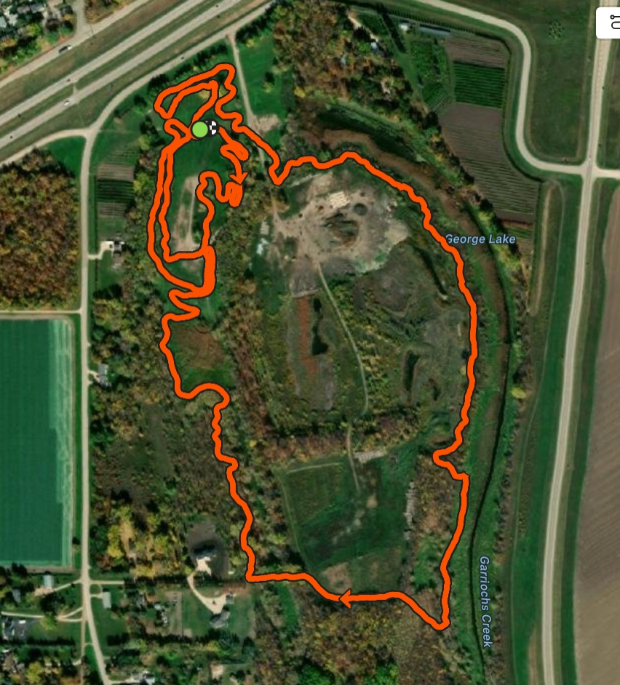

Kids race course ~ 1.4km loop

2, 3 or 5 lap options (subject to change). Typically, not more than 30 minutes for the long option. Duration range between short & long is typically 12-30 minutes.
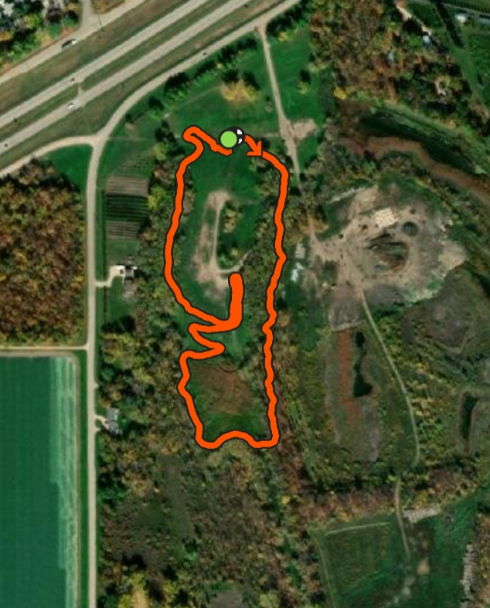

Rider Confirmation and Sign In

- Rider confirmation will take place in the picnic shelter at Prairie Flow Bike Park
- Registration will open at 6:00 and close ½ hour before your race time.

Awards
- Kids race:
- Prizing offered as random cash draw, 3 x $10 at each event. All participants will be offered candy.
- Grand Prize Draw of $200 for U13 will be drawn at the final Wednesday Night Race Series event, July 22, 2026 at Bird’s Hill Park. The more Wednesday night races you participate in, the more entries you earn for the draw!

- Adult race:
- Prizing offered as random cash draw, 3 x $20 at each event.
- Grand Prize Draw of $300 for adults will be drawn at the final Wednesday Night Race Series event, July 22, 2026 at Bird’s Hill Park. The more Wednesday night races you participate in, the more entries you earn for the draw!

Number Placement

All riders must secure their number plate to the front of the bike with the top at the handlebars. Plates should be in flat and in front of cables if possible.
Secure all four corners of the plate
Ensure you remove the plate before driving home with the bike on a rack, the plate will tear off and disappear.

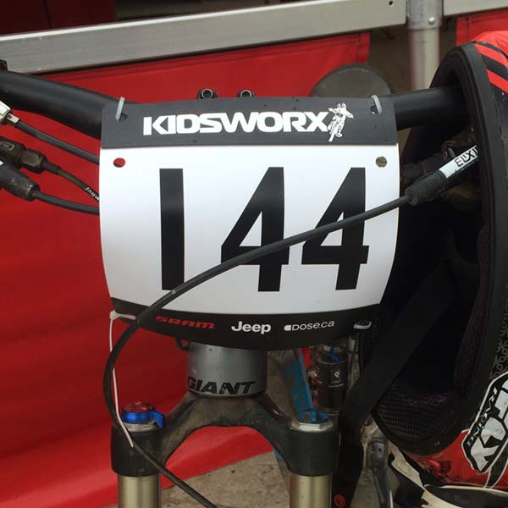

Event and Course Safety

First aid will be provided by Canadian Ski Patrol.

For your safety, if you withdraw from the event for any reason, you must
inform the nearest commissaire that you will no longer be racing. Riders not
reporting to the commissaire may be subject to a fine

Spectator Safety

Spectators should always remain off the racecourse and remain behind any
fencing around the course. For your safety there is no climbing and hanging onto structures not
designed for those purposes. No spectator should be accessing the racecourse any point throughout the event.

Manitoba Cycling does not permit any alcohol consumption at the event. Please refrain
from bringing and consuming any alcohol during the event and throughout
the event grounds including the racecourse.

Hospital Location

Portage District General Hospital
524 5th St SE, Portage La Prairie
204-239-2211

General Race Rules: -

Riders are required to wear a hard-shell ANSI or SNELL approved helmet while racing, warming up, and cooling down.

Riders must wear close-toed shoes and use a bike with front and rear brakes.

Sleeveless shirts/jerseys are not permitted.

Riders must be able to carry their own nutrition and water bottles with them on their bikes.

A waiver MUST be filled out and signed for each racer.

Courtesy and Safety:

The racecourse is open to the public.

Signs will indicate that a bike race is in progress, marshals do not have the authority to prevent people or vehicles from entering the course.

Ride within the designated route. Ensure you ride safely, in control. Cyclists deemed to be riding unsafely, discourteously, or recklessly will be removed.

If you choose to stop while on course, signal to the riders behind and pull over safely as far as possible onto the right side of the course. Our support team (ride marshals, medical staff) may ask if you need assistance. Signal with a “Thumbs-up” to indicate that you are okay.

Maintain control and speed of your bike, even when going downhill.

Be aware of others around you and communicate well in advance while cycling. Use gestures combined with verbal commands. Ride your head up and look down the course rather than directly at the person in front of you. Verbally say, “passing on your left” when passing another person.

You can not prevent a rider from passing you. Please move to the side of the course and allow them to pass. Not doing so can result in you being disqualified.

Know your limits. Crashes can occur when inexperienced riders lack the bikehandling skills necessary to make quick decisions in a pack.

Never overlap your wheels with another cyclist.

Be courteous to all vehicles and pedestrians.

Do not use headphones, personal stereos, or cell phones while riding.

Spectators cannot provide race support and will result in the racer being disqualified. Mechanical and feed support is only available in the designated areas.

Emergency vehicles ALWAYS have the right of way. Riders must give way to emergency vehicles by pulling over, stopping, and dismounting.

Always display your RACE number. All registered cyclists must wear their RACE number according to race instructions. Riders who fail to do so will not receive an official finish time

Onboard Technology

The following are MB Cycling regulations for onboard technology for all MB Cycling events which are managed by MB Cycling Commissaires. These regulations do not apply to any events which do not require Commissaires, but if they are sanctioned under the MB Cycling Insurance
Policy.

1. All onboard technology device which is fitted on a bicycle must:
a. Be installed on a system designed specifically for bicycles and not
affect the certification of any item on the bicycle.
b. Not cause a risk for the safety of any rider, and therefore, be affixed in
a manner that ensures it is not susceptible of inadvertently
dismounting or is non-removable.
c. The camera footage is not immediately available to the rider.

1. No onboard technology is allowed to be affixed to the helmet.

2. If a Commissaire feels that the technology is not properly affixed or safely
secured, they may, at their discretion, ask the rider to either remove the
technology or ask them to readjust to ensure that the device is safely affixed.

3. If there is a crash during an event, permission must be secured in writing
from the individuals involved before posting any footage from the incident.

4. It is strongly recommended that anyone who is using footage for individual
promotion or private use, secure written consent in advance from any
individual appearing on the footage.

5. Note:
a. MB Cycling Insurance does not cover loss or damages which may occur to
onboard technology during the event.
b. All individuals using onboard technology are responsible and liable for
any damages and injuries which may occur if the technology interferes
with the integrity and safety of the event.

