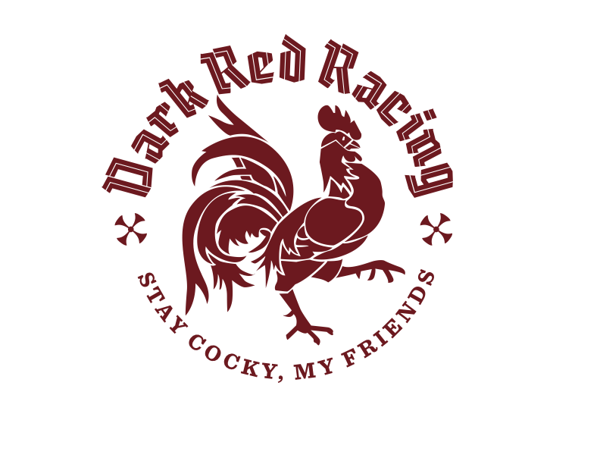

Dark Red Racing Team Time Trial   
**2017 Race Bible:**

**Date:** Wednesday, June 21, 2017

**Location:** Bird’s Hill Park

**Race Fees:** $10.00 per rider (Cash or Cheque payable to Dark Red Racing)

**Registration:** On-site only. Registration opens at 6 pm, closes at 6:30 pm  
 First team to start at 7:00 pm.

**Teams:** Three or four (but preferably four) riders per team, but note that the   
Finishing time is marked when the **third** rider crosses the line.

No restrictions as to age, gender, or ability in putting together teams.

**Course:** Start/Finish at the Pan Am start (top of the hill).    
Registration, pre-race staging and parking will all take place in the East Beach parking lot.

Main Event will be 3 laps of the park, clockwise; approx. 33.5 km.   
Teams may also opt to do either 1 or 2 lap events.

**Rules:** • Teams will ride as far to the right of the road as possible, except when overtaking a slower team.   
• Teams being overtaken may not deviate from a straight line or otherwise impede an overtaking team.   
• At no time may either team draft the other.   
• No hand-ups allowed; mechanical assistance may only take place at the start/finish, and only after the rider has pulled off the course.   
• Dropped riders may not rejoin their team after falling a lap back.   
• Aero bars are allowed. Disc brakes are NOT.

**Prizing:** Team: Awarded for outstanding camaraderie and team spirit.*  
 Time: Fastest time in the main, 3 lap, event  
 Trial: Awarded for outstanding sportsmanship in the face of adversity,   
 or overcoming significant hardship in the course of the race.*  
 * Awarded at the organizer’s discretion

**Eligibility: You must hold a current UCI/CCA racing licence (including Kids of Mud)   
or an MCA citizen licence.**

Waiver MUST be filled out and signed for each racer.

Riders are required to wear a hard-shell ANSI or SNELL approved helmet while racing, warming up, and cooling down.

**Courtesy   
and Safety:**

The courses are open and the public can access the course at any point. Signs will indicate that bike race is in progress, but marshalls do not have authority to prevent people from entering the course. Keep your head up at all times. Be courteous to all vehicles and pedestrians.

**Organizers/Contact:**

Dark Red Racing

Andrea Tétrault, 204-899-0708 or andrea@tetrodesign.com

Mike Giesbrecht, 204-792-5396 or lockviewbuilds@gmail.com