Grand Pointe Road Race
Organizer: Lindsay Argue
(204) 782-4386
lindsayargue@gmail.com
Date: June 13, July 5, August 16, 2017
Location: Check in and staging will be at Fraser’s Auto 1477 Hallama Dr, Grande Pointe, MB R5A 1H9
Directions: Head south from the Perimeter on HWY 59. Grande Pointe is the first turn-off on your right after crossing the floodway. Once you enter Grande Pointe turn right at the stop sign and Fraser’s Auto will be on your left.
Parking: In the Fraser’s Auto Service parking lot.
Washrooms: There is an outhouse facility at the Grande Pointe Park.
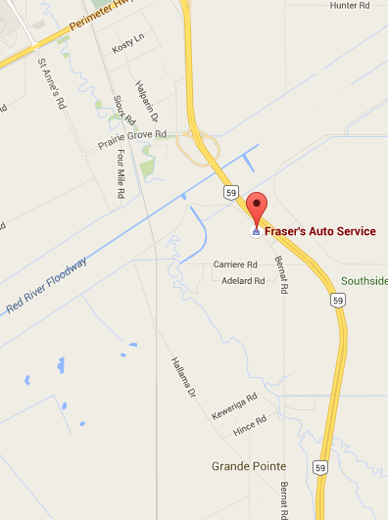 | 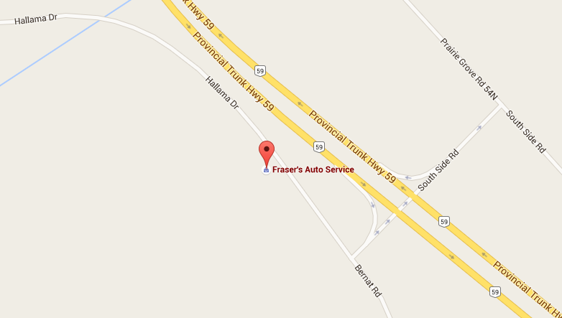  Park and Race Start/Finish Area

Eligibility: This race is open to all licensed MCA members.
Pre Registration: On site registration only
Registration: Registration will be on-site from 5:30pm until 6:30pm. Download a registration form and waiver and bring it with you.
Cost: 20$ race entry fee.
Race start times:
- 6:55pm – Cat 1/2/3
- 7:00pm– Cat 4
- 7:05pm– Cat 5/Citizen
Race course: The course consists of Bernat Rd and Hallama Dr in Grande Point. This forms a 9 km loop.
The Start/Finish will be near race HQ
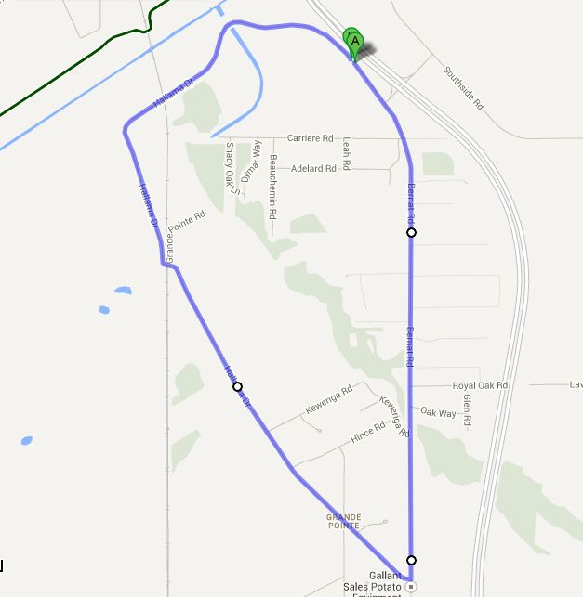
Distances: Race distances are as follows:
- Cat 1/2/3 – 8 laps (72 km)
- Cat 4 – 6 laps (54 km)
- Cat 5/Citizen – 4 laps (36 km)
Prizing: Prizing will be divided for each category.
Numbers: Two jersey numbers must be pinned on the right side of the jersey.

