2017 MCA Provincial Road Championships

The MCA is pleased to announce that the 2017 Provincial Road Championships will take place on Sunday August 27, 2017

Date: Sunday August 27, 2017
Host Club: Manitoba Cycling Provincial Program

Race Organizer: Jayson Gillespie: (204) 333-5503; cycling.coach@sportmanitoba.ca
Dave Lipchen: (204) 250-5107; mca.development.coach@gmail.com
Location / Parking: Grand Point Loop
- Sign in and registration will be at Fraser’s Auto on the east side of the loop, just north of the Hwy 59 exit.

Fraser’s Auto
1477 Hallama Drive
Grand Point, MB

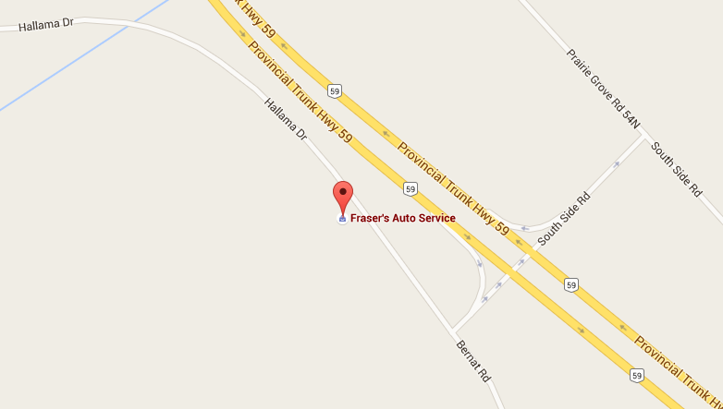
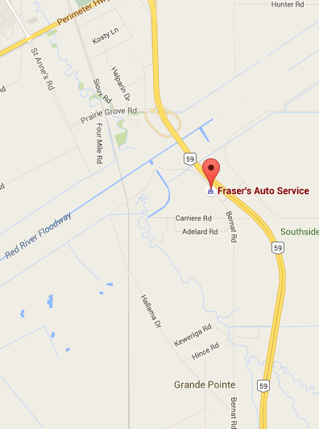
Park and Race Start/Finish Area
Park and Race Start/Finish Area

Registration: A UCI Racing License is required. You must hold a valid UCI race license. A citizen’s license or MCA general membership is not valid for Provincial Championships. Riders with a UCI racing license issued by a cycling federation other than Manitoba (including other countries) may compete, but are not eligible for medals. Day licenses are not available for provincial events.

You must complete the race registration form and race waiver. Pre-registration is highly recommended and is available on the MCA website. Please look for the “Register Now” button on the Provincial Event Calendar.

Cost:
- Pre-registration online: $25
- Pre-registration will be open until Thursday August 14th at 11:59pm.
- Race day until 9:30 am, $30 Cash only
- Full payment must accompany registration.

Sign-In: All racers must still sign-in the morning of the race. All riders must show their license to the commissaries. Sign-in will start at 8:30am and will end at 9:30am.

Washrooms: There will be a port a potty on site.

Race Distances:
- Age categories are determined by your age as of December 31, 2017.
- A number of categories may race together, but you compete only against others in your age and sex category.
- Each loop of the Course is 9km

-Riders will assemble at the sign-in area after which they will complete the prescribed number of laps.

Groups
- Group 1 - U23 MEN, Senior MEN, Master 30+ MEN
- 108km, 12 laps
- Group 2 Junior MEN, Master 40+ MEN, Master 50+ MEN, Senior WOMEN
- 90km or 10 laps·
- Group 3 U17 MEN & WOMEN, Junior WOMEN, All Master WOMEN, Master 60+ MEN
- 63km or 7 laps
- Group 4: U15 Men & Women
- 36 km or 4 laps

Start Times: 10:00am for Group 1, followed a few minutes later by Group 2, and then by Group 3, and then Group 4
- Riders will assemble before the start time for roll call and final instructions

Safety: The race takes place on an active road. Marshals do not have the authority to force vehicles to stop. Keep your head up at all times. It is the rider’s responsibility to ensure it is safe to proceed.
- Riders are required to wear a helmet while racing, warming up, and cooling down.
- Please do not mill around on the road before or after your race. It is a traffic hazard and discourteous to riders still racing and to drivers.
Feed Zone:
- Feeding is not permitted in the first 50km, and last 20 km.
- Weather conditions may warrant open feeding, to be determined on race day

Medals: will be awarded to the top 3 riders in each category, medal ceremony will take place after the conclusion of all races.

Official Notes:
- No rider support vehicles are allowed on the course except for those provided by the organizer.
- Provincials is an extremely competitive event, but it is a sporting event and rules of sportsmanship prevail:
- There are 180̊ turn-arounds at each end of the course.
- Riders have a responsibility to look after one another's safety.
- Riders have a responsibility to ensure there is adequate space before attempting to pass between or around other riders.
- Riders shall not intentionally impede the progress of other riders
- The course is an out and back race course, the yellow line rule will be in effect at all times

Race course: The course consists of Bernat Rd and Hallama Dr in Grande Point. This forms a 9 km loop. The Start/Finish will be near race HQ
